DATE COMPLETED _______
Volunteer Application Form

- Personal Details:
Title Mr/Mrs/Ms/Miss/Dr/Other
First Name(s)
Surname
Date of Birth
Address
Postcode
Telephone Number
Email Address
- Please asterisk your preferred method of contact above  Are you a member of The Linen Hall |  |  | Yes |  | No

- How did you hear about volunteering at the Library (please tick):
Experience of the Library |  | The Linen Hall Website
Article in Library Newspaper |  | Recommended by staff/volunteer
Volunteer Centre |  | Library member
Social Media |  | Other (please specify)

3. Skills and Experience
Please give a brief description of your interests or skills (e.g. language other than English) that you feel are of relevance to The Linen Hall.
4.Please indicate the type of volunteering you are interested in
Meet and Greet |  | Events
Tours |  | Linen Hall Charity Bookshop
5. Please indicate your general availability (please tick):
Any Day |  | Flexible |  | Evening
Weekdays |  | Morning |  | All Day
Weekends |  | Afternoon
How much time on any given day would you anticipate volunteering (please tick)?
Flexible |  | 1hr |  | 2h |  | 3h |  | 4h |  | 5h |  | 6h |  | 7h |  | 8h |  | >8hours
6. Referee
Please give the name of someone who can be contacted for a reference. Referees should be able to comment on your suitability for the role and should not be a member of your family.
Referee Full Name
Address
Postcode
Telephone Number
Country
Email Address
How long have you known this person?
In what capacity do you know this person?
7. Emergency Contact
Title Mr/Mrs/Ms/Miss/Dr/Other
First Name(s)
Surname
Relationship (Parent/Friend/Spouse/Partner/Other)
Address
Postcode
Country
Telephone Number

8. Data Protection
The information you have provided will be kept confidential. The Linen Hall is registered under the Data Protection Act. With your permission, we may use this data to keep you informed of other news concerning The Linen Hall.
If you would prefer not to receive these mailings, please tick here
I hereby give permission for my details to be stored on the Linen Hall Library’s database.
Signature |  | Date (dd/mm/yy) | / /

Please return your completed application to:
Volunteer Liaison Officer
Linen Hall Library
17 Donegall Square North
Belfast
BT1 5GB
Volunteer Co-ordinator Volunteer.Co-ordinator@linenhall.com
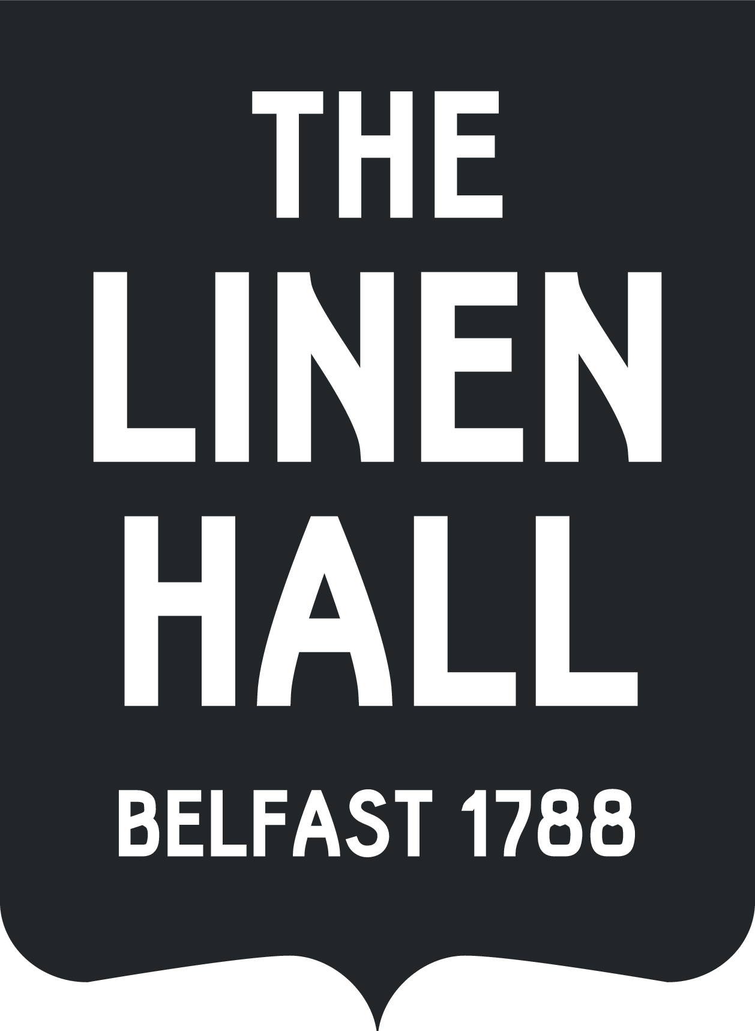

For internal office use.
Contacted on:
Interviewed :

